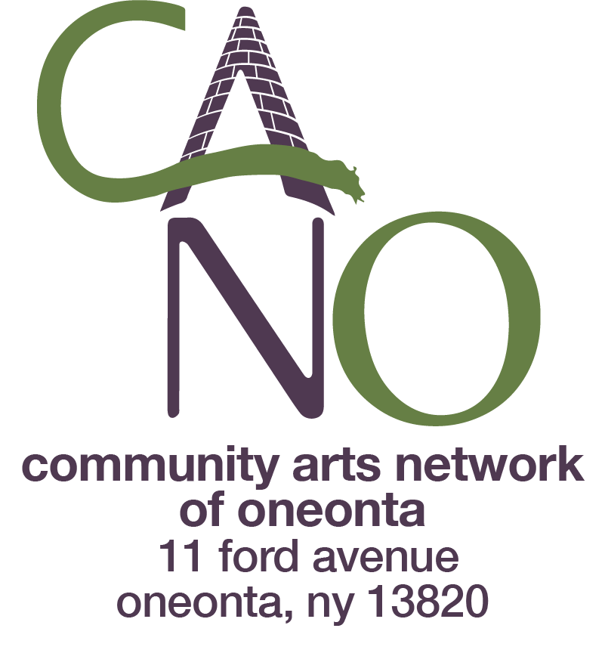
Summer Visual Art Program for Kids 6-10
Summer Arts Workshops for Kids 6-10
Summer Arts Program for Teens
Parents’/Guardians’ names:___________________________________________________
Child/Teen for whom scholarship is requested:________________________________
Age of Child/Teen:__________________________________________________________
Program(s) you wish to enroll your child/teen in (include dates and preference)_
_____________________________________________________________________________
Home Address of child/teen:_________________________________________________
Parent/Guardian email:________________________________________________________
Parent/Guardian phone: ______________________________________________________
Are you a CANO Household Member?_________________________________________
What was your family’s gross income last year?: $______________________________ Number of people in household?: ______________________________________________ Net income, if farming or otherwise self-employed?: ____________________________
Special circumstances we should be aware of:__________________________________ ______________________________________________________________________________
What amount of scholarship assistance are you requesting? $__________________
I attest that the above statements are true.
Signature of parent or guardian______________________________________ Date______________
Please email a copy of this form to admin@canoneonta.org. We will determine scholarship awards based solely on need and available funding. Please feel free to contact us with any questions: admin@canoneonta.org
Fill out a separate form for each child/teen in your household.

